# CS 255 System Design Document Template

This template lays out all the different sections that you need to complete for Project Two. Each section has guidance to prompt your thinking. You will need to continually reference the interview transcript as you work to make sure that you are addressing your client’s needs. There is no required length for the final document. Instead the goal is to complete each section based on what your client’s needs are. Remove this note when you are finished, and replace all bracketed text with the relevant information.

## UML Diagrams

### UML Use Case Diagram

### UML Activity Diagrams

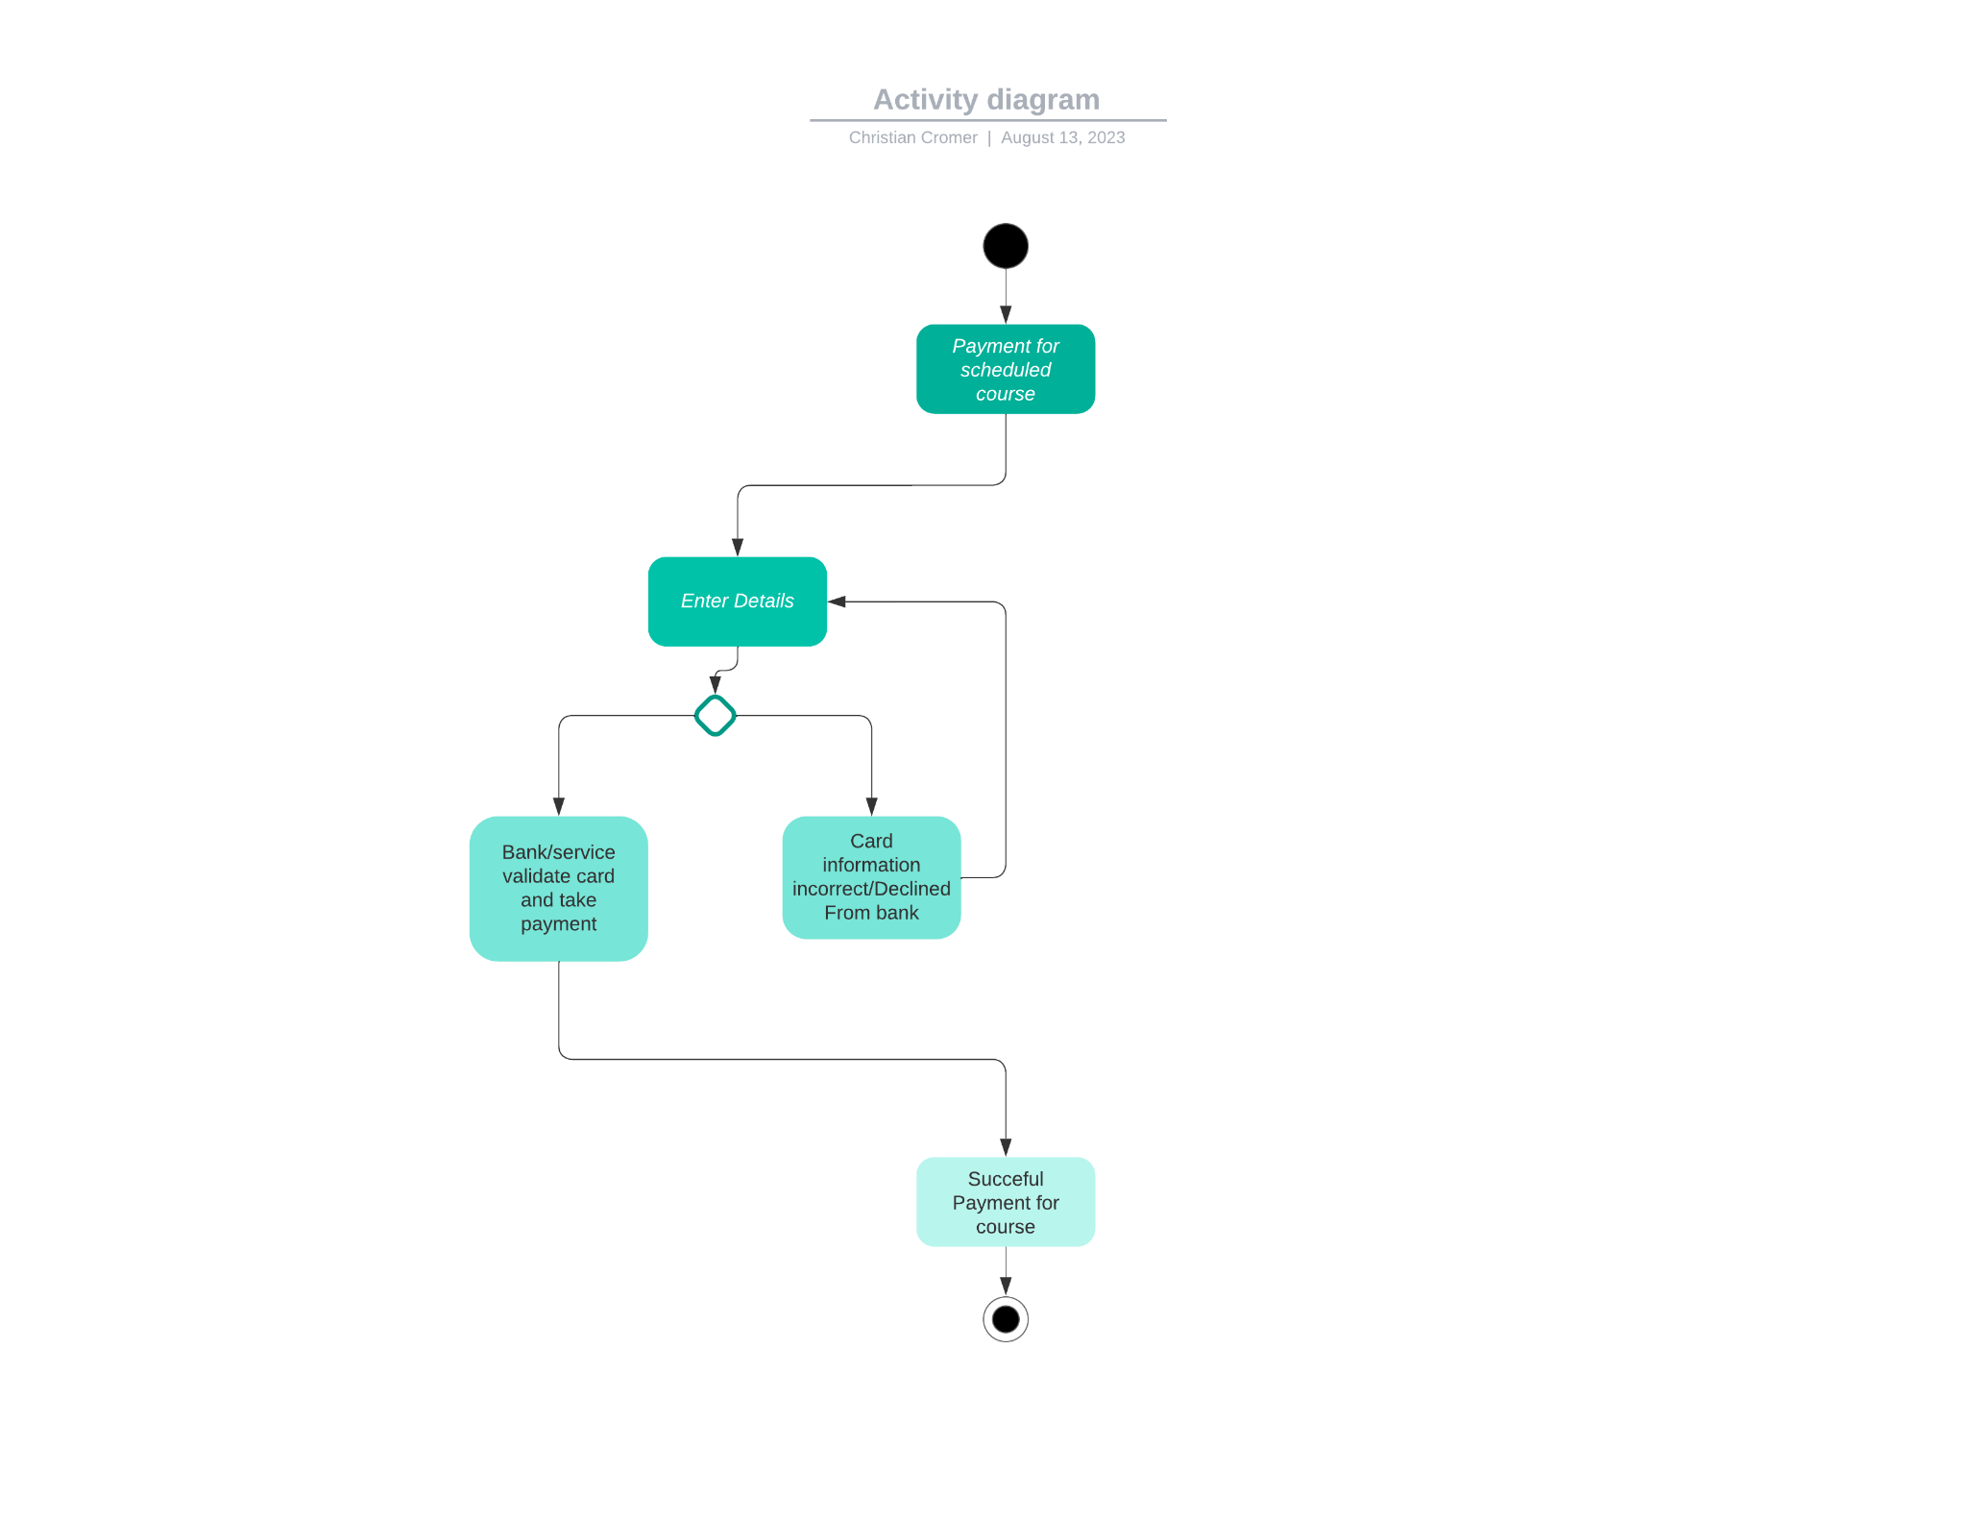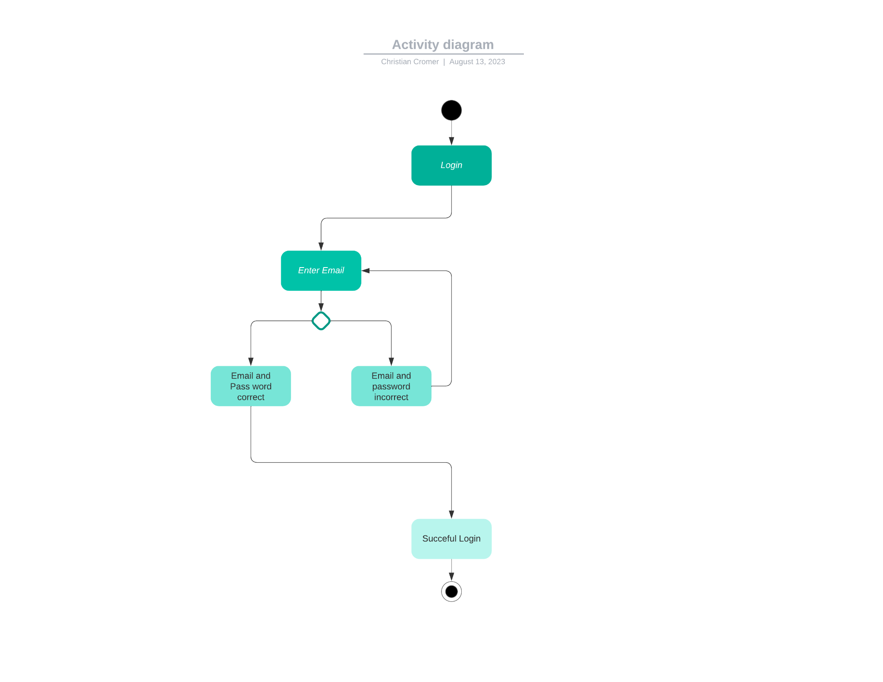

### UML Sequence Diagram

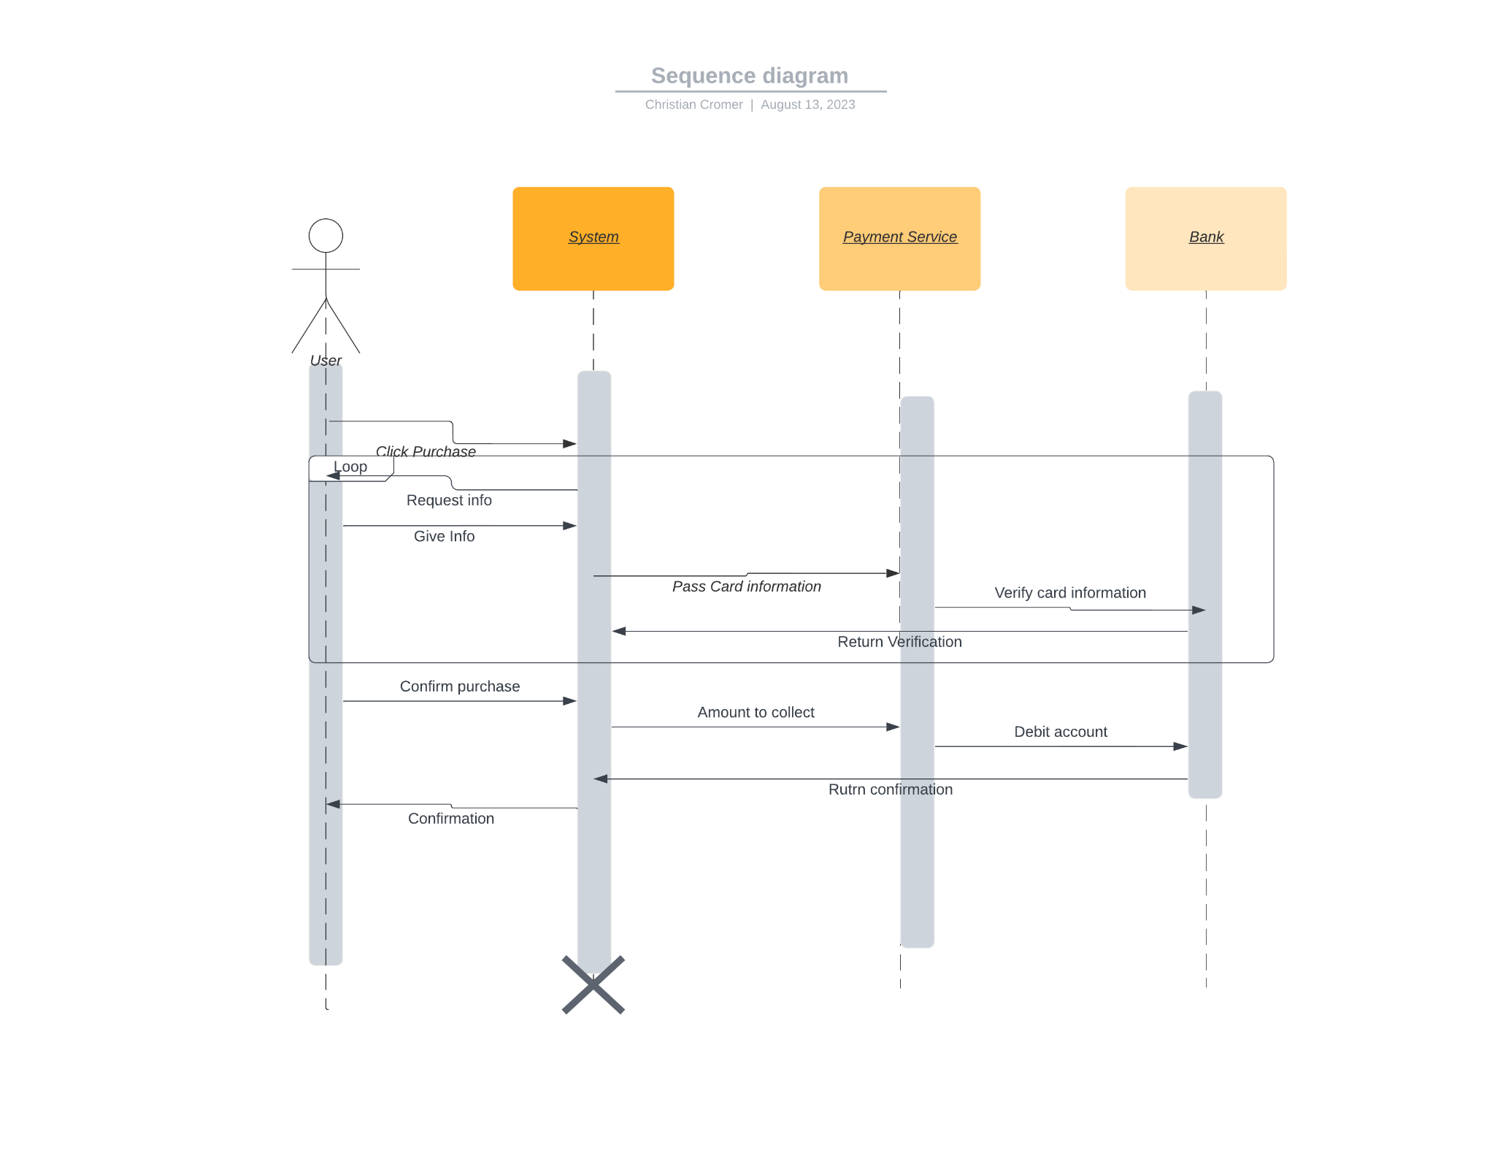

### UML Class Diagram

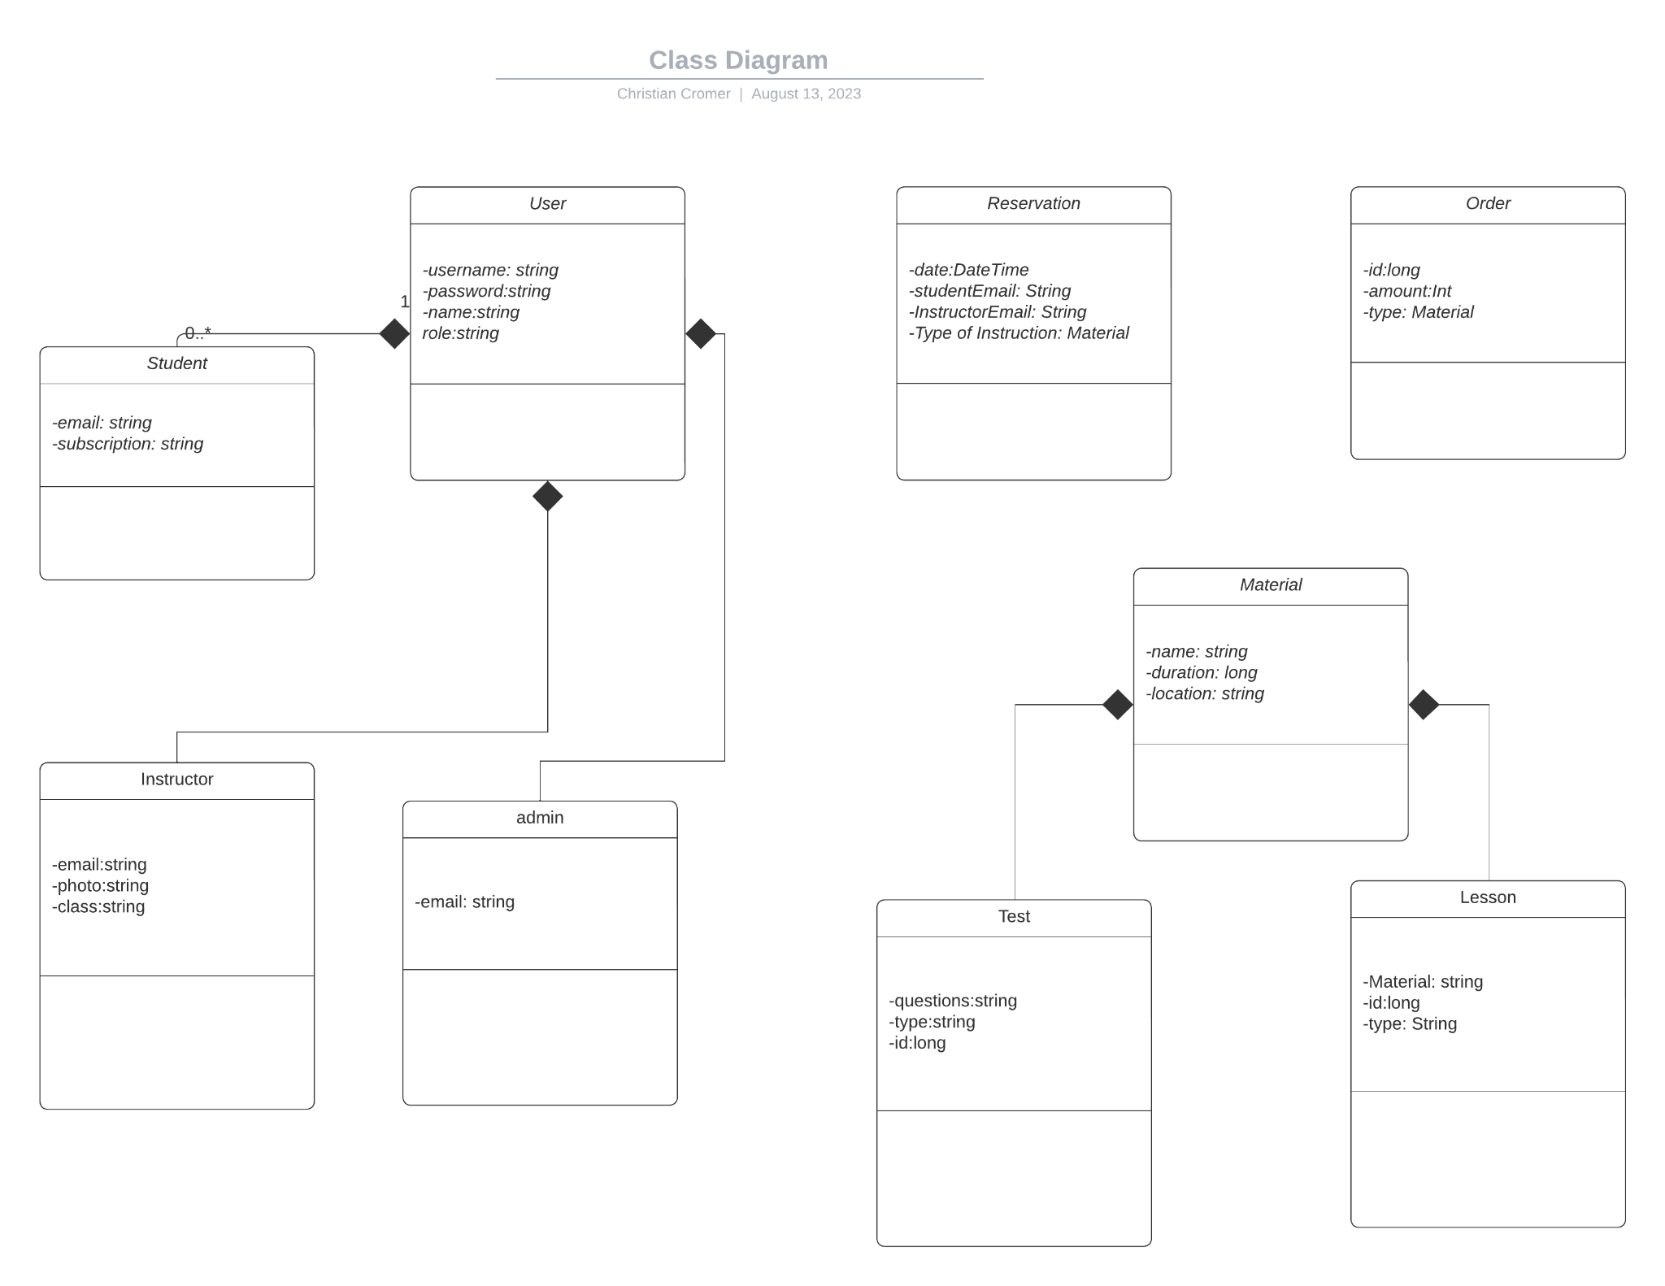

## Technical Requirements

* Web based application using Restful API’s to secure end points
* 0Auth2 integration for user authentication
* Payment portal integration such as pay pal or stripe to handle payments securely
* Database system to handle both material and order information.
* Role based authentication to implement admin and instructors to have different access to endpoints.
* Scalable database to handle more material and orders as needed.
* popular calendar integrations into applications to handle reservations. This will also be stored in the database.
* hardware would be a cloud based solution to deploy web apps such as azure or amazon or google firebase.
* advanced logging system to be able to track changes and orders from customers and admins alike.